1. ER-Diagram Overview
The Entity-Relationship (ER) Diagram for the AI Hotel Reservation System outlines the core data structure and relationships between key entities. The database is designed to support seamless user interactions, real-time bookings, and AI-driven recommendations while maintaining data integrity and performance.
2. Key Entities
- User
  - Stores user profiles, authentication details, and personal information.
  - Linked to Booking, Notification, and AI Recommendation for personalized experiences.
- Hotel
  - Contains hotel details (name, location, rating) and external API references.
  - Relates to Room (availability) and Deal (promotions).
- Booking
  - Manages reservation records, check-in/out dates, and payment status.
  - Connects User and Room to track occupancy.
- AI Recommendation
  - Stores AI-generated suggestions (e.g., hotel matches based on user history).
  - References User and Hotel to tailor results.
- Notification
  - Handles alerts (booking confirmations, deals) with read/unread status.
  - Tied to User for targeted communication.

3. Relationships
- One-to-Many:
  - User → Booking (one user, multiple bookings).
  - Hotel → Room (one hotel, multiple room types).
- Many-to-Many:
  - Deal → Hotel (promotions apply to multiple hotels).

- Why This Design?
  - Scalability: Structured to accommodate future features (e.g., reviews, loyalty programs).
  - Performance: Optimized for high-frequency queries (e.g., real-time room availability checks)
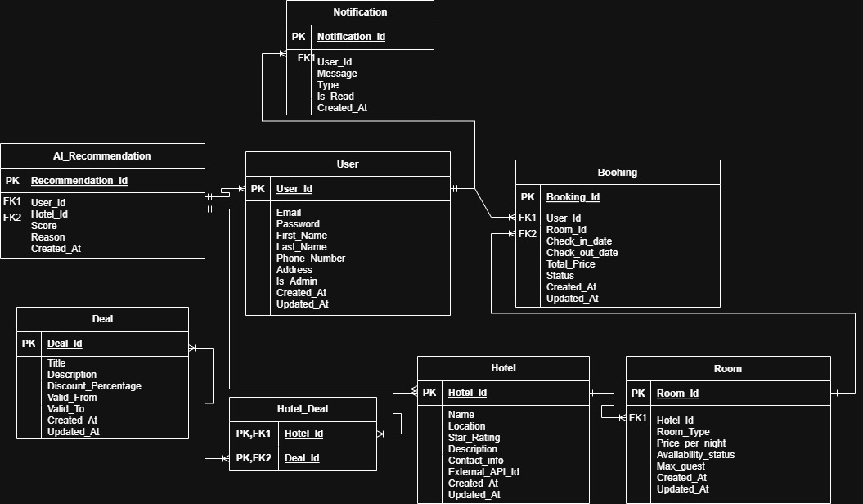

Figure 1: ER-Design for Hotel System Reservations.

